**Assignment 2 – Accessibility Game Pitch**

**Pitch**

I propose to create a story-based learning game for children with hearing impairment and reading difficulties or dyslexia. The game will relate short stories using text and sign (language) pictures.

When the story finishes, there will be a quiz to challenge the player. The quiz will involve multiple choice questions such as ‘What colour was the main character’s jacket?’. Sign pictures will accompany the questions to provide support. Correct answers will be awarded points and stickers.

There will be an easily accessible, and extensive settings menu including font sizes, types, and background colour. Importantly, there will be an option to hide sign components on reading and answers cards if the player is feeling confident.

**Research**

**Hearing impairment**

According to the World Health Organization (WHO):

Over 450 million or 5% of the world’s population have disabling hearing loss, 34 million of which are children. 60% of childhood hearing loss is due to preventable causes. The effects of hearing loss could be reduced by early identification and the use of hearing aids, cochlear implants, captioning and sign language, and other forms of educational and social support.

**Dyslexia and learning difficulties**

The International Dyslexia Association describes dyslexia as a language-based learning disability. Dyslexia encompasses many symptoms which result in people having difficulties with specific language skills, particularly reading. Students with dyslexia usually experience difficulties with language skills such as spelling, writing and pronouncing words.

There are many forms of dyslexia. Examples of the struggles someone with dyslexia might face include:

* Trying to recognise phonemes which are basic sounds such as ‘b’ in bat
* Words appearing blended together, backwards or jumbled as though the spaces are lost
* Trouble remembering things like phone numbers and names
* Trouble with orientation such as left from right and interpreting maps

The Australian Dyslexia Association (ADA) reports that dyslexia affects 10% of the Australian population and is the most common cause of reading, writing, and spelling difficulties. They say that findings from Canada state 80-90% of children that require learning support have dyslexia.

**Dyslexia friendly game design**

The World Wide Web Consortium (W3C) – an international community that develops online web standards - performed a study on how text customisation and background colours can improve readability for people with dyslexia. To extract data, they used a combination of a questionnaire and eye tracking technology.

The study showed that people with dyslexia prefer low brightness and strong colour differences among text and background. They found that black text with cream or yellow backgrounds were the best combinations for dyslexic people to read.

Another study was undertaken by a web research group from Barcelona on the presentation of text and its effect on accessibility for people with dyslexia.

They found that good fonts for people with dyslexia are Verdana, Helvetica, Courier and Arial based on reading speed (assessed using eye-tracking) and subjective preferences. Another finding was that italic fonts significantly reduced reading performance.

**Sign language**

The first formal teaching of sign language was in 1755 using Old French Sign Language. Currently, there are more than 300 different sign-languages, with each country or region often having differences. The alphabet is the same for major English-speaking countries; Auslan (Australian), BSL (British Sign Language) and ASL (American Sign Language), but many of the signs for words are different. While I’d love to reach as many children as possible, I will initially focus on Auslan to cater for Australian children.

**Is it common for children with hearing impairment to experience reading difficulties including dyslexia?**

A study by the Nuffield Foundation – a charitable trust focused on improving social well-being through projects in education and social policy - was done with 141 deaf children between the ages of 11 and 12. 82 of these communicated verbally (oral deaf) and 59 used sign language. Of the two groups 48% of the oral deaf children and 82% of the signing children showed below average reading levels. Another important finding was that spelling is often a relative strength of deaf children and may offer a means of improving literacy.

**Research summary in conjunction with my game proposal**

I believe the game I propose has the potential to provide support to deaf children with reading difficulties or dyslexia by combining several suggestions from the aforementioned studies through a customisable reading space that offers a fun way to improve memory, spelling and decoding skills.

There are 18 schools in Victoria that have deaf facilities or are specialist deaf schools and many more in other Australian states whose students are likely to benefit from this game.

**Platform and accessibility**

The game will be initially targeted to PC and tablet, because larger screens allow for larger font sizes and sign pictures for the best readability.

**Audience**

Australian children from the ages of 6 to 12 who are hearing impaired and dyslexic or have reading difficulties. In particular, it will be targeted at those who sign with Auslan.

**Aesthetics**

The aesthetics will be pictures and text from the original books in the top two thirds of the screen, combined with the sign pictures in the lower third. The main menu will show the covers of a range books that can be read. Interfaces will be minimalist as research has shown that people with dyslexia can be overwhelmed by lots of information.

**Mechanics / gameplay**

A typical game will consist of the following:

* The player will log in or create a username (to monitor / retain progress) and choose a story to read
* The story will be related using text and sign pictures
* Players can progress through the story by using the settings where they click next or choose a speed and the story is told to them
* A quiz component will ask the user to select a difficulty mode
* The quiz will ask questions of varying difficulty such as ‘What was the main character’s name?’ with a picture of the character
* Answers will be a mix of multiple choice and spelling cards depending on difficulty. They can toggle sign pictures on and off for assistance.
* Points will be awarded for partial and fully correct answers. The correct answer will be shown after answering even when correct, to reinforce learning
* When the quiz is finished, the player will be shown their rewards chart containing stickers for achievements like ‘One book completed on easy mode’ and ‘1000 points reached’

Like in many popular computer games, I believe a reward system will provide additional motivation for children to keep challenging themselves, and in doing so to improve their literacy skills.

As shown in the wireframe on the next page, the player can use the text helper to select a word by clicking on it or using the arrow buttons. This will enlarge it and display it in bold. This will also display the sign picture for the word.

Also shown is an ‘eye’ icon (below the sign picture) which can be used to toggle sign pictures on and off.

**Basic gameplay wireframe**

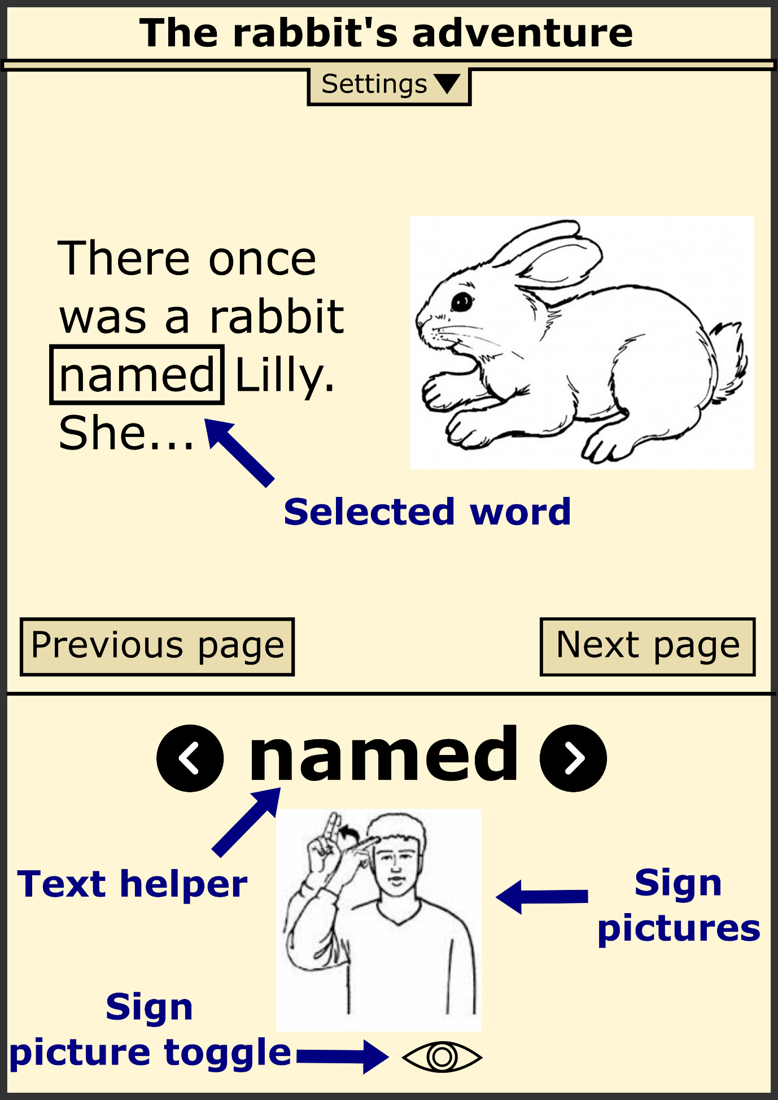

**Settings**

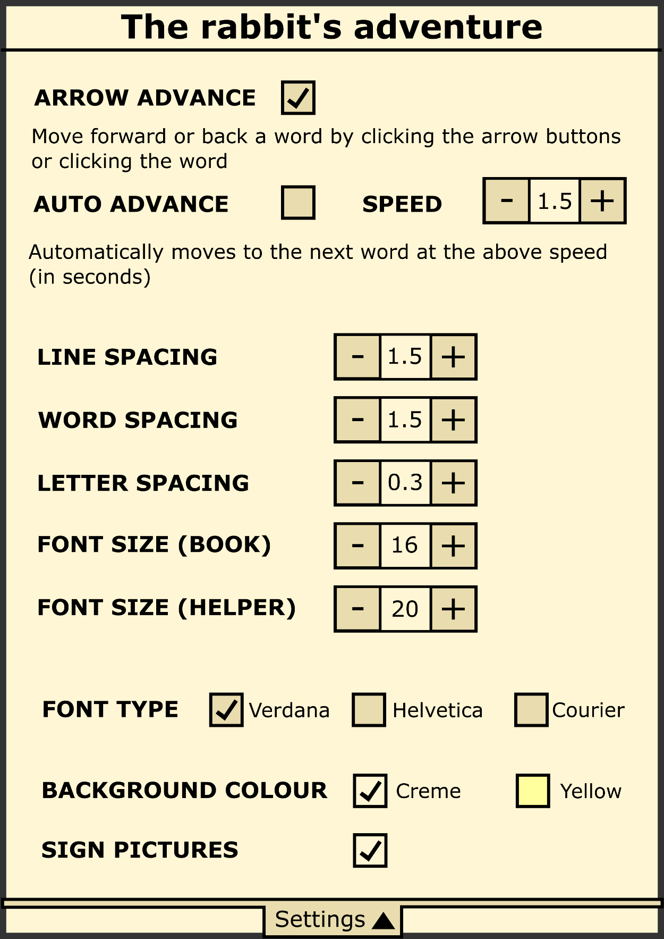The settings menu is one of the most important elements of the game in allowing the player to create an experience for themselves that is as comfortable and enjoyable as possible.

**Wrap up**

In a fully realised version of the game, I’d like to provide many different spoken and signed languages. According to the World Federation of the Deaf, 80% of the total deaf population are from developing countries, meaning this game would have the greatest impact when catering to those countries.

I understand access to computers or tablets may be an economic issue for children in developing countries, but a UK-based company called DataWind in conjunction with the Indian institute of Technology has created tablets to sell at a price of $35.

The Indian government recently bought and handed out 500 of the tablets to students who will test them. The human resource development minister said they planned to buy 100,000 of the devices and had the intention to distribute 10 million of them to students over the next few years.

I believe this could pave the way for many cheaper computing devices in the future that would reduce economic barriers for children in developing countries.

Finally, it would be great to include popular children’s stories to provide deaf children with more shared experiences alongside the mainstream population.

**References**

*Dyslexia in Australia*, Australian Dyslexia Association, viewed 23/05/2020, <<https://dyslexiaassociation.org.au/dyslexia-in-australia/>>

Herman, R, Roy, P & Kyle F 2017, ‘Reading and Dyslexia in Deaf Children’, University of London, pp. 1-21, Viewed 19/05/2020, <<https://www.nuffieldfoundation.org/wp-content/uploads/2017/11/Summary-Reading-and-dyslexia-in-deaf-children.pdf>>

Rello, L & Baeza-Yates, R 2012, *Optimal colours to improve readability for people with dyslexia*, World Wide Web Consortium, Viewed 17/05/2020, <<https://www.w3.org/WAI/RD/2012/text-customization/r11>>

Rello, L & Baeza-Yates, R 2013, ‘Good Fonts for Dyslexia’, Proceedings of the 15th International ACM SIGACCESS Conference on Computers and Accessibility, pp. 14:1-14:8, Viewed 16/05/2020, <<http://dyslexiahelp.umich.edu/sites/default/files/good_fonts_for_dyslexia_study.pdf>>

Vaughan, G 2020, *Deafness and hearing loss*, World Health Organisation, viewed 20/05/2020, <<https://www.who.int/news-room/fact-sheets/detail/deafness-and-hearing-loss>>